Homework 3
Charlotte
23 October 2015
library(ggplot2)

Q1 Two sample t-test
cdc <- read.csv(url('http://stat511.cwick.co.nz/homeworks/cdc.csv'))
cdc$wt_diff <- with(cdc, weight - wtdesire)
t.test(wt_diff ~ exerany, data = cdc, var.equal = TRUE)
##
## Two Sample t-test
##
## data: wt_diff by exerany
## t = 3.245, df = 998, p-value = 0.001213
## alternative hypothesis: true difference in means is not equal to 0
## 95 percent confidence interval:
## 2.175386 8.831608
## sample estimates:
## mean in group 0 mean in group 1
## 18.08602 12.58252
(1pt for code)

Statistical Summary:
There is strong evidence to suggest that the mean desired weight loss for those who exercised in the last month is not equal to the mean desired weight loss for those who did not exercise in the last month (two sample t-test statistic = 3.245, df = 998, p = 0.001).
It is estimated that those who exercised in the last month have a mean desired weight loss 5.5 lbs lower than those who did not exercise in the last month.
With 95% confidence the mean desired weight loss for those who exercised in the last month is between 2.2 and 8.8 lbs lower than the mean desired weight loss of those who did not exercise in the last month.
(3pts summary)

Q2 A Randomization Test

Parts 1 and 2)
(1pt for each part: groupings, test-stats, null dist , p-value, summary, study design)
## Placebo scores New drug Scores Test statistic
## 1 0, 3 0, 3, 9 2.5
## 2 0, 0 3, 3, 9 5.0
## 3 0, 3 3, 0, 9 2.5
## 4 0, 9 3, 0, 3 -2.5
## 5 3, 0 0, 3, 9 2.5
## 6 3, 3 0, 0, 9 0.0
## 7 3, 9 0, 0, 3 -5.0
## 8 0, 3 0, 3, 9 2.5
## 9 0, 9 0, 3, 3 -2.5
## 10 3, 9 0, 3, 0 -5.0

Part 3)
Since, the patients were randomly assigned to groups, all 10 random combinations of patients to two groups (size 2 and 3) are equally likely to occur. So, the test-statistics from these 10 groupings represent the randomization distribution. By assuming the null hypothesis is true, we are able to calculate these test statistics because if the effect of the new drug does not differ from the effect of the placebo, then the 5 patients' observed BP changes would occur no matter which treatment they were assigned to (e.g., no matter what group subject A was in we would observe a reduction in BP of 0).
These test statistics are therefore the randomization distribution assuming the null is true, by definition the null distribution. The null distribution is plotted below (not required).
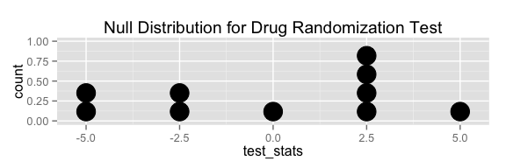

Part 4)
The observed test statistic is 2.5. In total there were 9 random groupings that gave a test-statistic as extreme or more extreme than the observed test-statistic (i.e. further or as far from zero). p-value = 9/10 = 0.9.

Part 5)
There is no evidence to suggest that the effect of the new drug differed from the effect of the placebo for patients in this study (randomization test, p = 0.9).

Part 6)
This experiment was poorly designed because there is no way to reject the null hypothesis given this study's null distribution. The smallest possible p-value we could get in this study is 1/10 = 0.10. A p-value of 0.10 is not small enough to reject the null hypothesis; therefore, given this data, there is no way to reject the null.

